Atoms – Protons, Neutrons, and Electrons
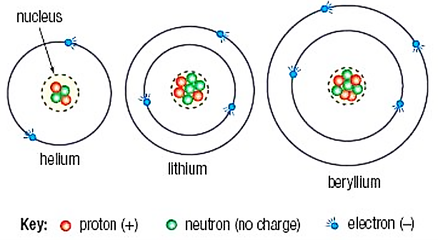
All material things are made from atoms. An atom is the very smallest particle which exists of an element. All of the atoms of any one element (say oxygen) are identical. Oxygen gas is made from trillions and trillions of identical oxygen atoms. There are only 90 naturally occurring different elements in the periodic table, so there are just over one hundred types of atoms in the universe.
Some of these are very rare, and most of the matter you can see is made up of only twenty or thirty common atoms. Luckily, atoms can join together in millions of different combinations to make all the substances on Earth and beyond.

Structure of the atom
Every atom is made of a nucleus consisting of protons and neutrons. The nucleus is surrounded by electrons.
It is the number of protons an atom has which gives it its identity, so for example, all oxygen atoms have exactly 8 protons.
Protons are positively charged and electrons are negatively charged. Neutrons have no charge. This means the nucleus (protons and neutrons) of an atom is positively charged. The negatively charged electrons move around the nucleus and are held in place by their attraction to the positively charged nucleus.
An atom has a neutral overall charge because it usually has the same number of electrons as protons (same number of negative and positive charges).
Protons and neutrons have the same mass. Electrons have such a small mass that this can usually be taken as zero.
 | Proton | Neutron | Electron
Charge | +1 | 0 | -1
“Relative”  Mass | 1 | 1 | 0.0005 (almost zero)

Comparing the charge and mass of electrons, protons and neutrons

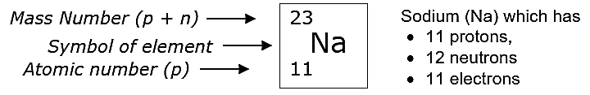
The atomic number is the number of protons in an atom. In a neutral atom (where the protons and electrons are equal in number) the number of electrons is also equal to the atomic number.
The mass number (also called the nucleon number) is the total number of protons and neutrons in an atom.

The elements are arranged in the periodic table in ascending (lowest to highest) order of atomic number - so it's easy to find the name or symbol for an atom if you know the atomic number.
VERY IMPORTANT: Elements are described mainly by their atomic numbers as this tells you where the atom is in the periodic table - and the number of electrons the atom has. The number of electrons is what determines the chemistry of the element – how it reacts, what it reacts with, and how many bonds it forms. Your teacher can explain this in more detail when you look at a periodic table.

